Teacher’s Guide - Healthy Diet

**Intended outcome:**

* Understand current diet practice in Dang District
* Understand the available alternatives and know what to eat
* Understand the importance of iron
* Know the nutritional values of the crops
* Know how to achieve a healthy diet

**Content:**

1. The function of nutrients related to iron deficiency anemia.
2. Introduction to nutrient contents of common crops and foods in Dang District.
3. Foods that enhance and inhibit the treatment of iron deficiency anemia.
4. Introduction to SIGHT’s recipes as alternative dishes.
5. Class organization

Opening (20 min)

**Goal:** Raising awareness of current eating habits in Dang District through an interactive game.

**Description:**

1. Giving out instructions and group division (5 min)
2. Game (10 min)
3. Punishment (5 min)

Game instructions: Assign students into groups of 5 or 6. Sit each group in circles, one person starts telling what his/ her name is and what he likes to eat; the next person repeats and adds on their own information; the third person repeats the information about the first two people and adds on his own; likewise for the whole circle. After completing a full circle, continue with the next topic of the game. The first person who fails to remember stands up (wait until each group has one person standing) and the whole class decides their punishments.

Topics for each round:

* name
* favorite food
* food they eat the most
* name of crops
* food they want to eat but never tried

Punishment can be decided by the rest of the class. No physical or forceful punishment (push up, truth or dare, etc.). Possible punishments: singing, dancing, telling a funny story.

Q/A session (5-10 min)

**Goal:** To show some consequences of having an unbalanced diet.

**Description:**

The teacher starts by giving out a statement to open up the Q/A session, then continues by asking different questions about healthy diet and observes students’ answers. The student should raise his/ her hand first and be appointed by the teacher before answering the question. Teacher will ask another student to answer if the previous answers are not correct or complete.

If nobody tries to answer out of confusion, the teacher may give some multiple choice options. If nobody answers correctly, the teacher can tell the answer directly.

Opening statement:

We all know that our bodies need energy to do our daily activities from playing, exercising, and studying. However, energy itself is not enough as the body still needs different elements to function. Just like a school that cannot function if there is only the building. It needs teachers, students, furniture, and curriculum to run properly. These energy and other elements can be acquired from a healthy diet.

Questions and their answers:

1. What does a healthy diet mean?

A healthy diet is one that provides the body with essential nutrition by eating the right amounts of nutrients on a proper schedule. This will help achieve the best performance and maximize good health.

Multiple choice answers:

* A diet that provides the body with essential nutrition.
* A diet that makes us sick.
* A diet that makes us full all the time.

1. What is the proper schedule?

Proper eating schedule means we eat in a constant routine everyday. Usually we eat 3 times a day (breakfast, lunch, and dinner) plus some snacks, and that is the one recommended for children. However, some adults may have different schedules, but it doesn’t really matter as long as it is consistent and all essential nutrition is fulfilled.

Multiple choice answers:

* A constant and routine eating schedule.
* Eating three times a day.
* Eating whenever feeling hungry.

1. Why do we need a healthy diet?

It allows people to consume essential nutrition that helps maintain or improve overall health by improving growth and development, increasing cognitive function (focus and concentration), and increasing energy and strength.Healthy diet can also help one recover from injury faster.

Multiple choice answers:

* It gives us energy and keeps us healthy.
* It makes us eat more.
* It makes us less hungry throughout the day.

1. What happens if we do not have a healthy diet?

Our health will be disturbed, so it is easy to get sick. The body will not have a lot of energy to perform daily activities.

Multiple choice answers:

* We get sick more easily.
* We are more active throughout the day.
* We can concentrate more when studying.

1. How to have a healthy diet?

Consume different varieties of foods that contain different nutrition in a consistent, routine eating schedule.

* Eat diverse foods in a routine schedule.
* Eat the same food everyday.
* Eat the most expensive food we can find.

Pre-assessment: (20-25 min)

**Goal:** To test students’ level of knowledge on nutrition and food.

**Description:**

1. Giving out instructions and group division (5 min)
2. Matching game (10-15 minutes)
3. Check answers (5 min)

Matching game instructions: Assign students into groups of 5 or 6 (preferably into different groups than the first game). We provide a piece of paper where students different smaller pieces of paper with pictures of crops and nutrition written on them. They will match as much and as accurately as they can and paste them onto the large paper that align with the dishes/ crops and decorate as they can.

Matching game paper example:

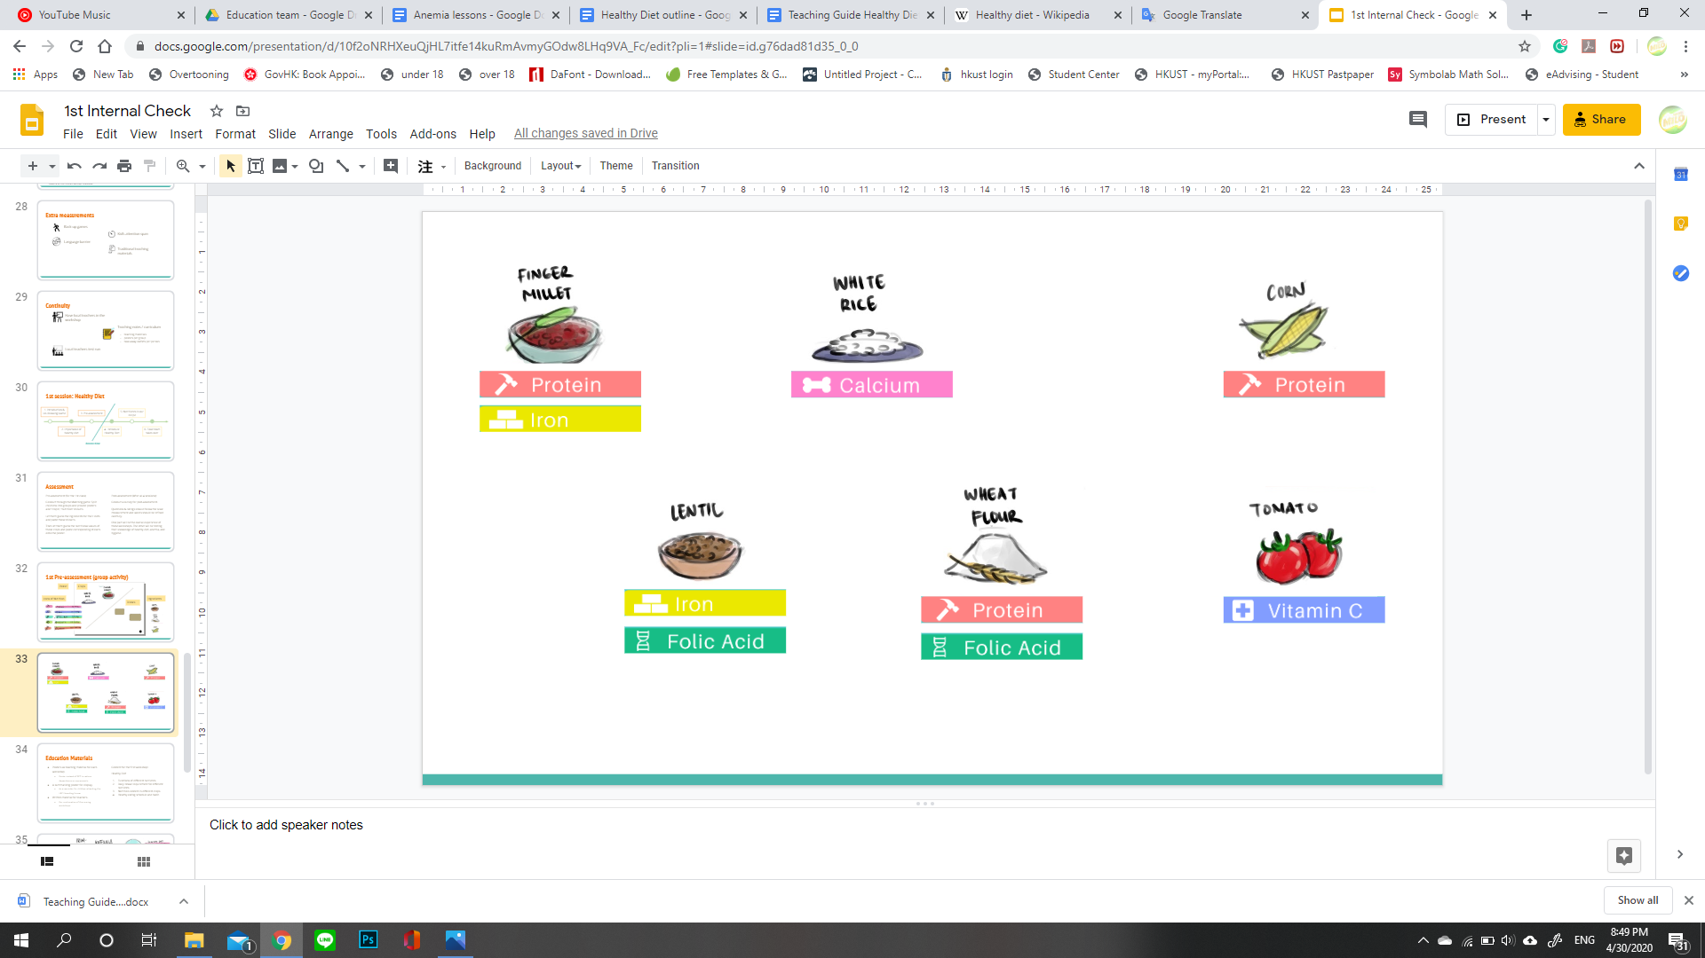

Throughout the game, teachers should look around the answers to see the general level of knowledge of the students. This can help determine the appropriate pace during the actual teaching activity.

Teaching (55 min)

**Description:** Teaching is done by teachers using available posters as presentation media or can be adjustable according to what works best in the class condition.

1. Storytelling (10 min)

Teacher tells a story to allow the students to understand how the relationships between certain nutrients work. Different characters’ pictures are the only presentation tools used in this storytelling activity.

After the storytelling, the teacher can add a conclusion of lesson learned from the story: Iron and folate play a big role when it comes to tackling anemia. However, the presence of calcium can inhibit the process, while on the other hand, vitamin C can help ease the process of iron absorption.

Characters of the story:

* Iraj (iron) as main hero
* Fohit (folate) as sidekick
* Vinita (vitamin C) as enhancer
* Calditi (calcium) as inhibitor
* Anemia as the villain
* Deepak as the boy

The story:

Iraj the iron is a secret nutrient-superhero that helps people become strong and healthy. He works together with his sidekick, Fohit the folate, every time there is a mission to help someone. However, unlike most heroes, Iraj is a very shy person. He always feels inferior compared to other nutrients because he is often considered too uptight. Fohit, on the other hand, is always too busy focusing on their mission so that he doesn’t pay much attention to his partner.

One day, Iraj and Fohit got a call to help a kid named Deepak who was kidnapped by an infamous villain, Anemia, because he didn’t consume healthy foods and ate without following an organized schedule. It had been a long time since Iraj got a mission last time that he felt nervous. This nerve became more extreme the time he realized that Calditi the calcium lived around the village where the kid was kidnapped. Iraj and Calditi have had a bad history that makes them dislike each other. Due to Iraj’s shy upbringing, he always tried to avoid her.

Fohit became very impatient because he knew the longer they waited, the more danger the kid was in. Luckily, Vinita the vitamin C, a close friend of Iraj heard the news and came by. She calmed Iraj so that he could relax and focus on what’s more important: saving the kid. Iraj pulled himself together and started going to the place where the kid was kept together with Fohit. They ran so fast that when in the middle of their way, Iraj was stopped by Calditi without Fohit realizing.

She stopped Iraj and started rambling about how much she hated him. Iraj got flustered and didn’t know what to do. Fohit who had already arrived at the location was surprised by the presence of Anemia. He started attacking her, but actually, he is no match to her. Iraj didn’t know what to do because Calditi was stubbornly blocking him.

Once again, Vinita saved the day by pulling and holding Calditi away from Iraj. Iraj started running as quickly as he could and helped his partner fight Anemia.

Eventually, after combining both of their strengths, they managed to defeat Anemia and saved the boy. They brought the boy back home and advised him to eat more healthily. The boy was very grateful for Iraj and Fohit, yet Iraj is grateful for Vinita. Without her, nothing would go as planned.

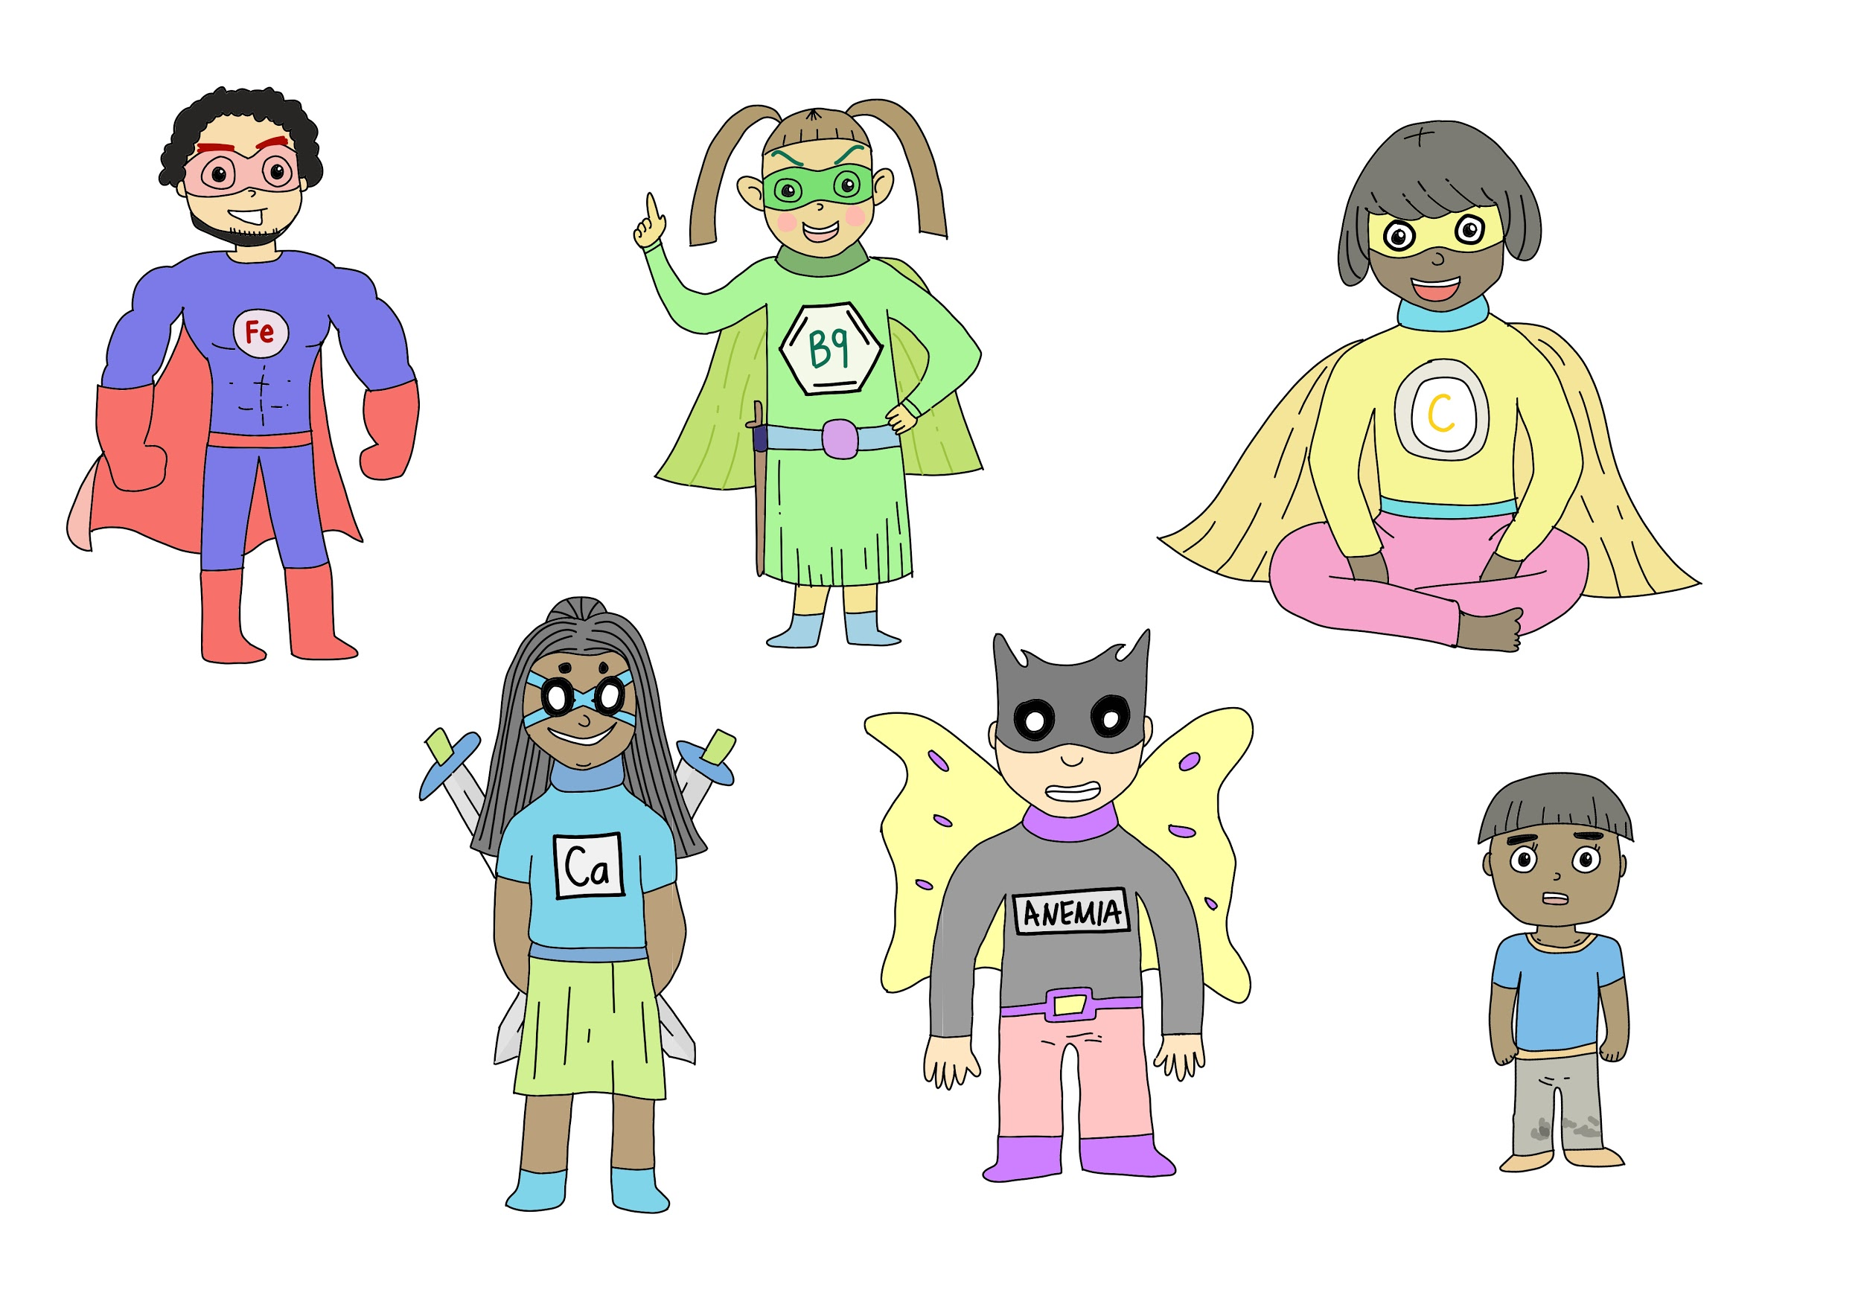

From upper left to lower right: Iraj, Fohit, Vinita, Calditi, Anemia, and Deepak

1. Introduction to functions of different nutrients (15 min)

Delivered verbally by the teacher and also written on the teaching board.

First the teacher reminds how different nutrients help the body become healthy in their own ways. Then write the names of different nutrients and what they are on the teaching board, starting from protein to folate. For example, “Proteins are building blocks of all the tissues, like muscles, bones, organs, and brains, which includes blood cell production as well.”

Exclusive for the iron part, after telling its function, a rhetorical question can be mentioned, “So some irons are hard to be absorbed. Is there any way to deal with this?”. After that, the teacher may move on to the vitamin C part.

1. What is protein?

Proteins are building blocks of all of the tissues (muscle, bones, organs, brain) which includes blood cells production as well.

1. What is iron?

Iron is a mineral needed by the human body to produce healthy red blood cells. Iron can be divided into two: heme and non-heme. Unlike heme, non-heme iron is hard to be absorbed by the body and needs enhancers to do so.

1. What is vitamin C?

Vitamin C is the main enhancer that allows non-heme iron to be absorbed by the body.

1. What is calcium?

Not only enhancer, there are also inhibitors of iron absorption and one of them is a mineral called calcium.

1. What is folate?

Folate, also known as vitamin B9 is needed to help red blood cell production and growth in general. Its manufactured form is called folic acid and can be found in IFA (iron and folic acid) supplements.

After writing down their definitions, the teacher asks, “ What is the function of iron?”. Students are allowed to guess, followed by the teacher's final answer which can be referred back to the story from the previous activity and to the list below. For example, “Iraj is just like iron that helps defeating anemia. It is an essential part of healthy red blood cell production that functions as an oxygen transporter throughout the body.” As protein is not mentioned in the story, referring back to it is not necessary.

1. Function of protein

Proteins keep the body healthy and strong, and also support growth and development.

1. Function of iron

It gives red blood cells the ability to carry oxygen throughout body tissues. In order for a red blood cell to be able to carry oxygen, it needs to have a protein structure in it called hemoglobin. Iron is an important component of hemoglobin and without it, hemoglobin cannot bond with oxygen.

1. Function of vitamin C

Vitamin C acts as an enhancer for iron to allow it to do its task. Vitamin C also increases the immune system of the body which reduces the risk of catching a disease.

1. Function of calcium

Calcium is actually not a bad thing because it is an important component of growing strong bones.

1. Function of folate

As folate has a role in cell division and growth, it is highly important during infancy and pregnancy.

1. Introduction to nutrition daily intake requirements and comparison on nutritional values of common crops in Dang. (10 min)

Delivered verbally by the teacher using the poster as a presentation tool.

* 1. **Daily Nutrition Requirements**

Each nutrient and its daily requirement are mentioned one by one while showing the poster. It is not necessary for the students to memorize all of it, but to allow them to refer back to a benchmark when they encounter more information about food they eat or recipes.

|  |  |  |
| --- | --- | --- |
| Nutrient | Function | Daily Requirement |
| Iron | Make hemoglobin to carry oxygen | 8-11 mg |
| Protein | Repair broken cell, building blocks | 46-56 g |
| Folate | Help red blood cell production | 0.4 mg = 400 mcg |
| Vitamin C | Increase immune system, help iron absorption | 65-90 mg |
| Calcium | Build strong bones, inhibit iron absorption | 1000-1300 mg |

* 1. **Nutrition Content**

Not all exact numbers should be mentioned, only the ones in bold.

* + 1. White rice

To show that white rice is not very nutritious compared to other crops and consuming it all the time can lead to certain deficiencies, especially iron deficiency.

* + 1. Finger millet

To show its exceptionally high iron content, which is important to produce healthy red blood cells.

* + 1. Tomato

To show that tomato and most other fruits are high in vitamin C and can help with iron absorption.

|  |  |  |  |  |  |
| --- | --- | --- | --- | --- | --- |
| Food (per 100 g) | Iron | Protein | Folate | Vitamin C | Calcium |
| **White rice** | **0.2 mg** | **2.7 g** | **1 mcg** | **0** | **10 mg** |
| **Finger millet** | **12.6 mg** | 7.6 g | - | - | - |
| Chickpea | 2.67 mg | 8.14 g | 158 mcg | 1.2 mg | 45 mg |
| Soybean | 1.11 mg | 7.17 g | 44 mcg | 0.2 mg | 111 mg |
| Corn | 2.71 mg | 9.42 g | 19 mcg | 0 | 7 mg |
| Lentil | 3.11 mg | 8.4 g | 169 mcg | 1.4 mg | 18 mg |
| Wheat flour | 1.17 mg | 10.33 g | 26 mcg | 0 | 15 mg |
| **Tomato** | 0.27 mg | 0.88 g | 15 mcg | **13.7 mg** | 10 mg |

1. Sources of protein, iron, and folate (10 min)

To further strengthen students’ knowledge of different nutrition sources, a simple game will be held. Students are divided into groups of 5 or 6. Each group will be given some random pictures of foods and asked to discuss with their group mates to decide which ones are the sources of certain nutrients (protein, iron, or folate). After the decisions are made, they can all stick the pictures into one big piece of paper which previously had been divided into three sections corresponding to each nutrient.

1. Source of proteins

Protein occurs in a wide range of food from animal products to legumes, nuts, and seeds: soybeans, lentils, chickpeas, corn, wheat, mung beans, and many others.

1. Source of iron

Both heme and nonheme irons can be found in animal products, such as red meat, poultry, fish, and other seafood. Non-heme iron comes exclusively from eggs or plants. HIgh-iron plants are finger millet/ ragi, chickpea, lentil, soybean and beans in general.

1. Sources of folate

Some plant sources high in folate are peanuts, sunflower seeds, lentils, chickpeas, spinach, lettuce, soybeans, and others.

1. Relationship between diet and iron deficiency anemia. (5 min)

Delivered verbally by the teacher.

Anemia is a condition of lack of healthy red blood cells in the body. Red blood cells have a protein called hemoglobin which functions as the transporter of oxygen throughout the body. Each hemoglobin is made of four heme molecules that each has an iron in the middle whose job is to bind the oxygen molecules. Iron can also help to store oxygen in the muscles and create energy. Lack of iron means not enough oxygen to give someone the energy to perform daily activities.

1. Enhancers and inhibitors of iron absorption. (5 min)

Delivered verbally by the teacher using the poster as a presentation tool.

* 1. **Enhancer**
     1. Enhancers should be consumed at the same time or near the time of iron consumption.
     2. Sources of vitamin C are fruits like mango, papaya, citrus, custard apple, etc.
  2. **Inhibitor**
     1. Inhibitors should not be consumed at the same time as iron consumption, should be at least one hour before or after.
     2. The main source of calcium is milk.
     3. Other substances found in tea, coffee, and cocoa (caffeine and polyphenols) also inhibit the absorption of iron.

Introduction to SIGHT’s recipes (15 min)

**Goal:** To familiarize the children with the dishes and give direct examples of the materials they had just learnt.

**Description:**

1. Handout distribution containing recipes of the foods and their nutritional values (3 min)
2. Ask the student to read the recipes by themselves (5 min)

Students who may struggle to read will be assisted by the teacher.

1. Pinpoint some nutritional values (7 min)

Teacher concludes the recipe and emphasizes certain nutrients e.g. iron and vitamin C to show how those dishes can help reduce the consequences of iron deficiency anemia.

